Bottom-up Integration Testing

📖 Definition
# Source: AI Source: Provided by: [Data Path: Persons Table -> ID Column: 1, Name_En Column: Motasem Essam] -> From: [ChatGPT] on [8/23/2025]
Bottom-up Integration Testing is an approach where testing starts with the lowest-level modules (the building blocks) and gradually integrates upward toward the main control module.

🔹 Characteristics
# Source: AI Source: Provided by: [Data Path: Persons Table -> ID Column: 1, Name_En Column: Motasem Essam] -> From: [ChatGPT] on [8/23/2025]
- Begins with unit-tested, low-level modules (e.g., database access, utility functions).
- Drivers (temporary programs) are used to simulate higher-level modules that aren’t yet developed.
- Modules are combined and tested in clusters (sometimes called builds).
- Progresses upwards until the entire system is integrated.

🔹 Objectives
# Source: AI Source: Provided by: [Data Path: Persons Table -> ID Column: 1, Name_En Column: Motasem Essam] -> From: [ChatGPT] on [8/23/2025]
- Verify correctness of low-level interactions early.
- Ensure data flow from bottom modules to higher modules works as expected.
- Reduce risk of missing defects in core “foundation” modules.

🔹 Example
# Source: AI Source: Provided by: [Data Path: Persons Table -> ID Column: 1, Name_En Column: Motasem Essam] -> From: [ChatGPT] on [8/23/2025]
Using the ATM system again:
- A (Top): User Interface
- B: Account Management
- C: Transaction Processing
- D: Balance Inquiry
- E: Withdrawal
- F: Deposit
🔹 Bottom-up approach:
- Start testing D, E, F (low-level modules). Use drivers to feed them input.
- Integrate D, E, F into C (Transaction Processing).
- Then integrate B (Account Management).
- Finally, integrate A (User Interface).
👉 At each stage, remove drivers once the higher module is ready.

🔹 Advantages
# Source: AI Source: Provided by: [Data Path: Persons Table -> ID Column: 1, Name_En Column: Motasem Essam] -> From: [ChatGPT] on [8/23/2025]
- Low-level modules tested first, so foundational issues are caught early.
- No need for stubs (which can be harder to build than drivers).
- Easier to test critical utility and service modules early.

🔹 Disadvantages
# Source: AI Source: Provided by: [Data Path: Persons Table -> ID Column: 1, Name_En Column: Motasem Essam] -> From: [ChatGPT] on [8/23/2025]
- The main control module (e.g., UI) is tested late → late prototype.
- Users/business can’t see an early working version.
- Interface errors with top-level modules may be discovered late.

⚖️ Quick Comparison (Top-down vs Bottom-up)
# Source: AI Source: Provided by: [Data Path: Persons Table -> ID Column: 1, Name_En Column: Motasem Essam] -> From: [ChatGPT] on [8/23/2025]
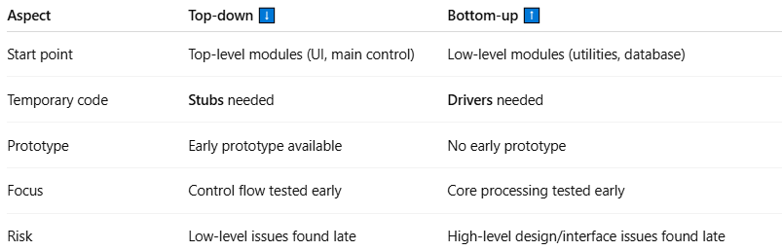
Aspect | Top-down ⬇️ | Bottom-up ⬆️
Start point | Top-level modules (UI, main control) | Low-level modules (utilities, database)
Temporary code | Stubs needed | Drivers needed
Prototype | Early prototype available | No early prototype
Focus | Control flow tested early | Core processing tested early
Risk | Low-level issues found late | High-level design/interface issues found late

✅ In short:
Bottom-up Integration Testing = Start from the bottom (low-level modules) → integrate upwards → replace drivers step by step until full system is tested.

